Software Requirement Specification

For

Petroleum Review System

Version 1.0

Prepared by Ishita Singh

**Table of Contents**

**1. Introduction**

1. Purpose
2. Intended Audience and Reading Suggestions
3. Product Scope
4. Definitions, abbreviations and acronyms
5. References

**2. Overall Description**

1. Product Functions
2. User Classes and Characteristics
3. Operating Environment
4. Design and Implementation Constraints

**3. External Interface Requirements**

1. User Interfaces
2. Hardware Interfaces
3. Software Interfaces
4. Communications Interfaces

**4. System Features**

1. Functional requirements

**Introduction**

**Purpose:**

Petroleum Review System is a software developed for the petrol pump,

which has a feature to convey the customer about the actual quantity

product delivered to the customer after fuelling. Similarly about the quality

of the product, if the product is off-specification. It has the facility to

measure the fuel quality and quantity and display it along with some quality

parameters too.

**Intended Audience and Reading Suggestions:**

This software is targeted towards the general public and the government officials. It allows the officials to gather data regarding the quality and quantity of the fuel supplied by each petrol pump with the help of sensor and aids the consumers in selecting the best-suited petrol pump according to the review generated for each of it.

**Product Scope:**

The consumers can select the best petrol pump by looking at the review of each of them and can also issue a complaint if they are unseated with the fuel quality. The government officials can take action against those petrol pumps with low reviews and can also monitor every petrol pump with the rating fluctuation caused by complaints.

**Definitions, abbreviations and acronyms:**

**References:**

**Overall Description**

**Product Functions:**

Review Generation:

The software accesses the current location of the user and shows all the petrol pumps nearby in a certain radius. The user then selects the petrol pump according to his preferences. The software searches for that particular petrol pump in the database and finds the keys associated with it. The software checks the sensor data and after parsing it, stores the processed information in columns corresponding to that key. This information is then processed to generate a review of that petrol pump.

Aiding Users in selecting petrol pumps:

By accessing the GPS location, the software shows a marker on the map pointing to the current location of the user and then shows all the petrol pump nearby. The value corresponding to the * notation gives the review of each petrol pump. The user can then select the petrol pump accordingly.

**User Classes and Characteristics:**

**Operating Environment:**

**Design and Implementation Constraints:**

**External Interface Requirements**

**User Interfaces:**

**Hardware Interfaces:**

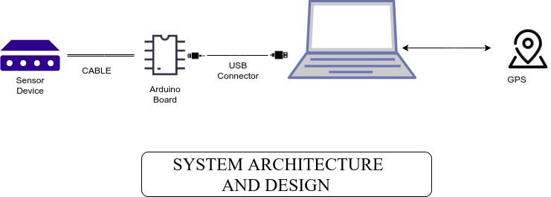

**Software Interfaces:**

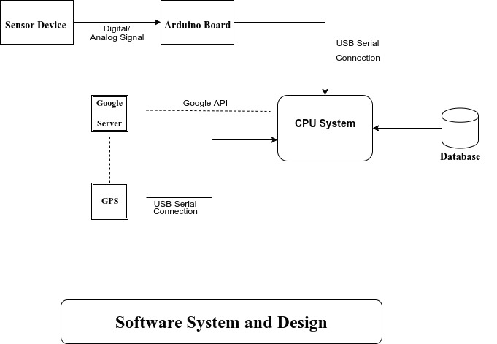

**Communications Interfaces:**

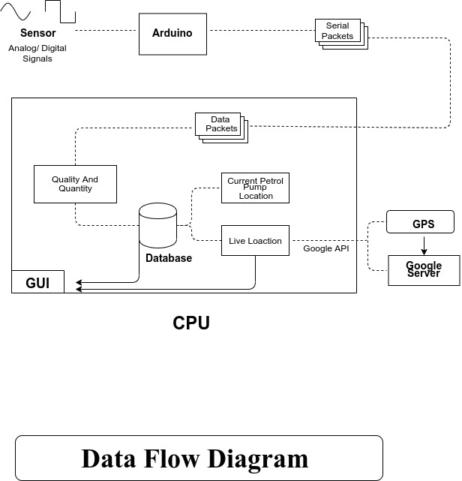

**System Features**

**Functional requirements:**